## Q-1: ProblemStatement:

Create a registration form for XYZ University. The form should look as shown in the image below.

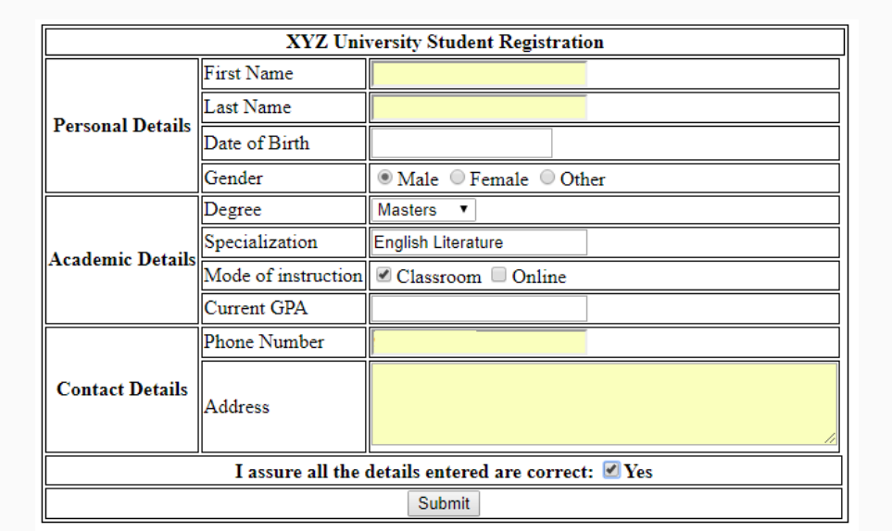

The validations for each field are described below:

* **First Name**: Required, max 10 characters
* **Last Name**: Required, max 10 characters
* **Date of birth**: Required
* **Gender**: Only one option must be selected
* **Degree**: Dropdown should contain "Bachelors", "Masters" and "Doctorate"
* **Specialization**: Required, max 40 characters
* **Current GPA**: Required, max value 5, increment in steps of 0.1
* **Phone Number**: Required
* **Address**: Required, max 4 rows of 40 characters each.

**All required fields should be marked with a red asterisk (*)**

## Q-2: ProblemStatement:

Create the below table for Destiny Tours & Travels price list.

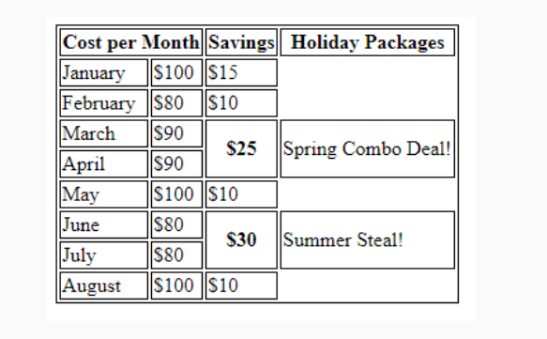

Q-3: ProblemStatement:

Create a form for XYZ online pizza delivery service as shown in the image below.The validations for each field are given below:

* **First Name:**Required, max 20 characters
* **Phone Number**: Required
* **Size**: Required, only one option can be selected
* **Base**: Required, Dropdown should contain "Pan Pizza", "Cheese Crust" and "Chicken Stuffed Crust"
* **Additional details**: contains 2 rows of 30 cols each.

All required fields must be marked with a red asterisk (*)

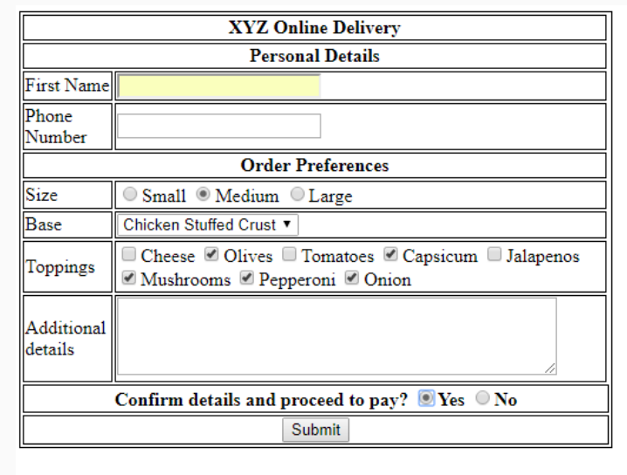

Q-4:PROBLEM STATEMENT – Create the below Form using HTML5 and CSS

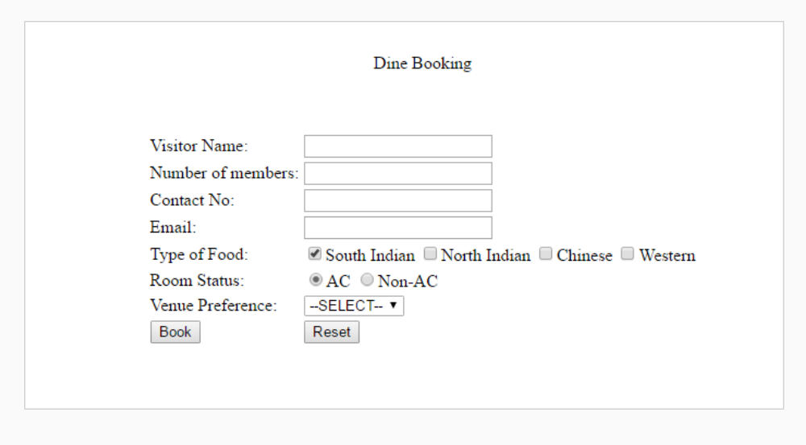

## Q-5: ProblemStatement:

Create the below page using **HTML5 semantic element and CSS3 Flexbox with SASS.**

Note: It should look similar to the page below.

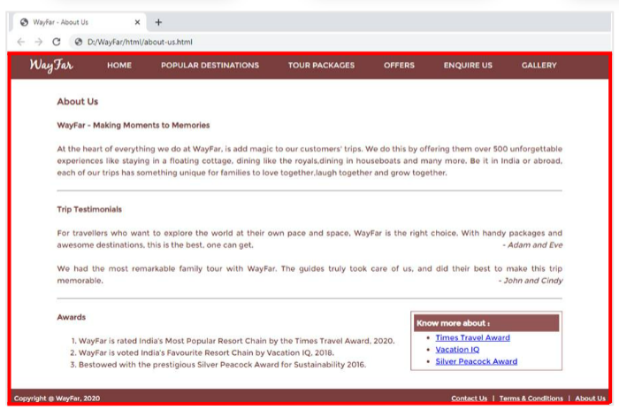

## Q-6: ProblemStatement:

Create the Contact Us page as shown below. Use HTML5,CSS3.

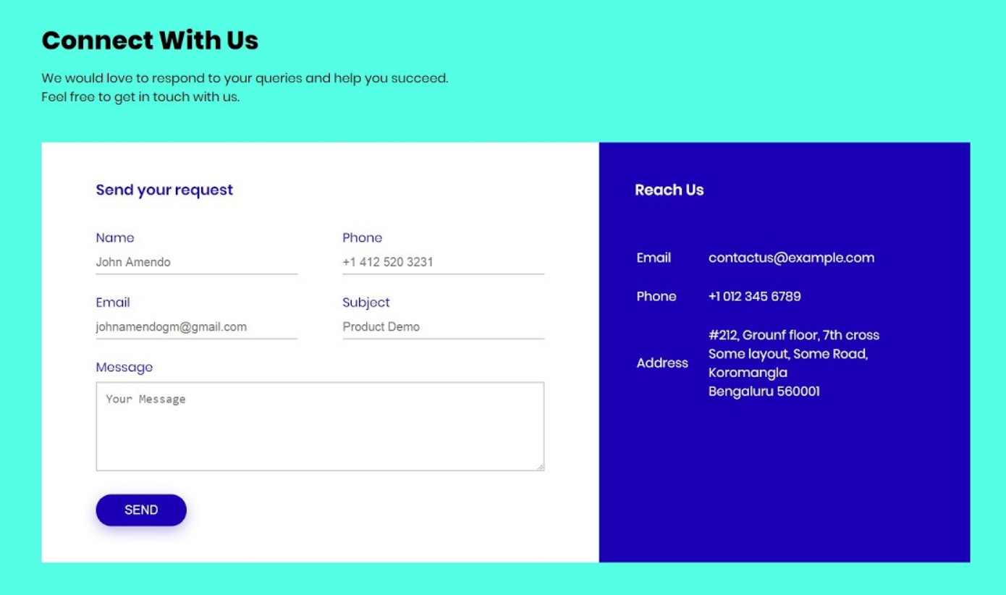

## Q-7: ProblemStatement: Create this page with these 3 cards using HTML5 and CSS3,Box Model,CSS3 Selectors.

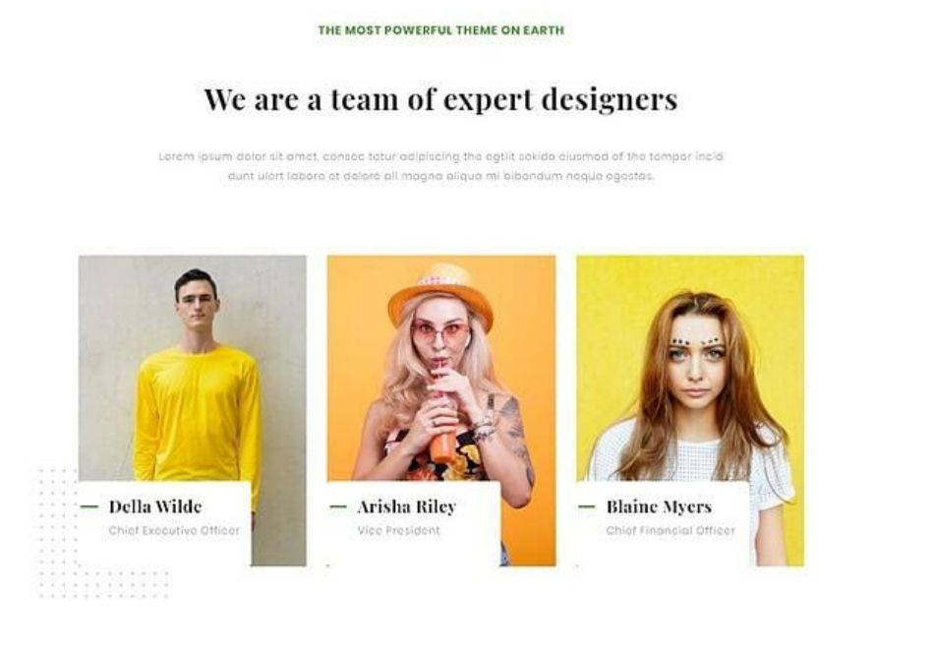

## Q-8: ProblemStatement: Create this page using HTML5 Semantic Elements and CSS3 Flexbox, Layout, Combinators,,Gradient.

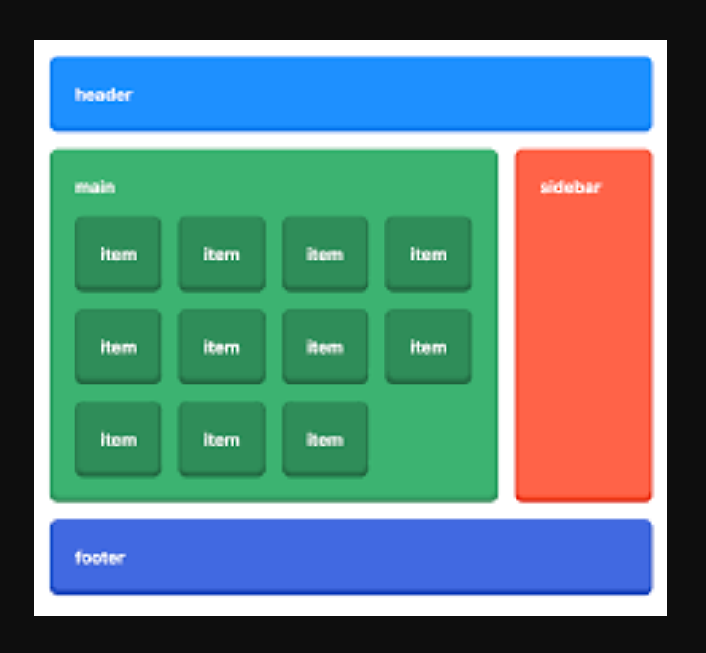

## Q-11: ProblemStatement:

**1. home.html**

This page renders the information about the company. It has a ‘Explore More’ button when clicked should take the user to services.html**. Here : Use Html5 Semantic Elements,CSS3 Selectors, Flexible Layout, Flexible images. Use SASS (CSS Preprocessor)**

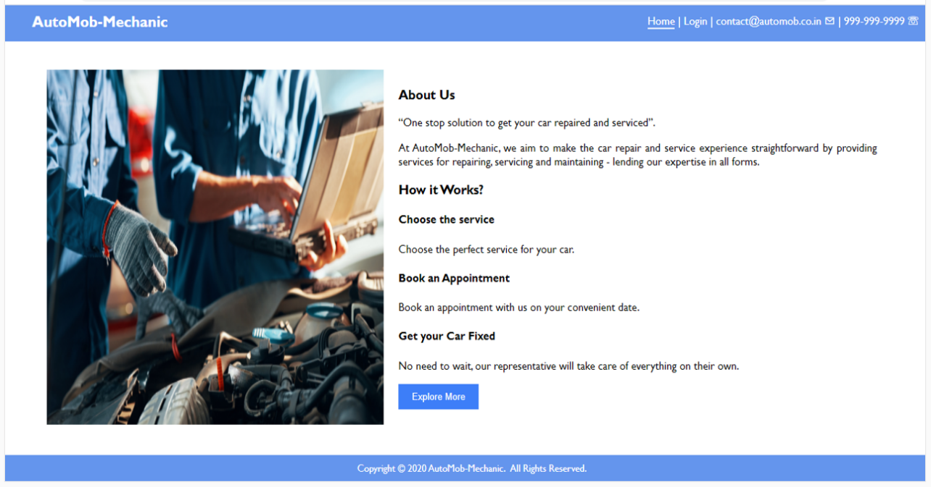

2.Services.html : Here you have to display the content as it is.

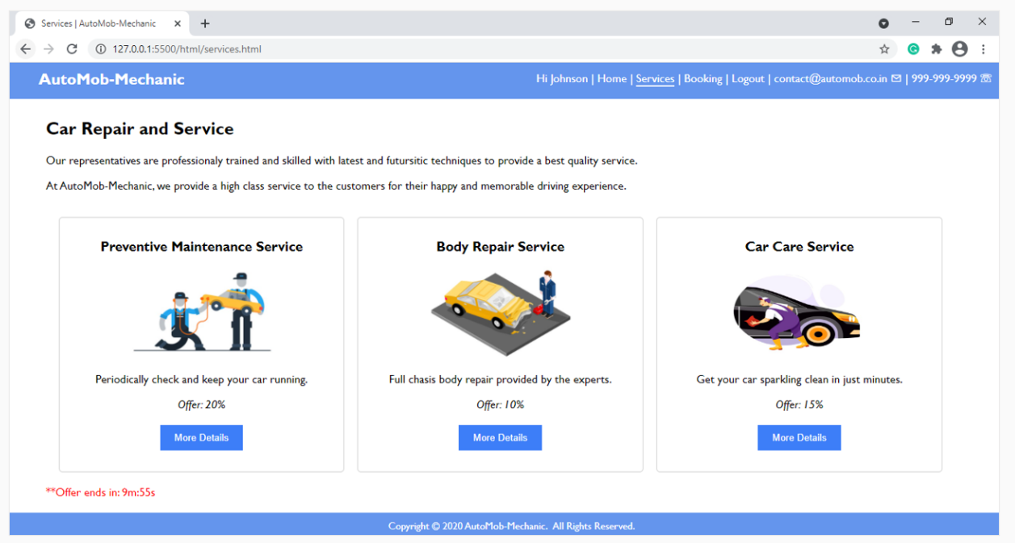

3. Reports.html – This page will render a table .

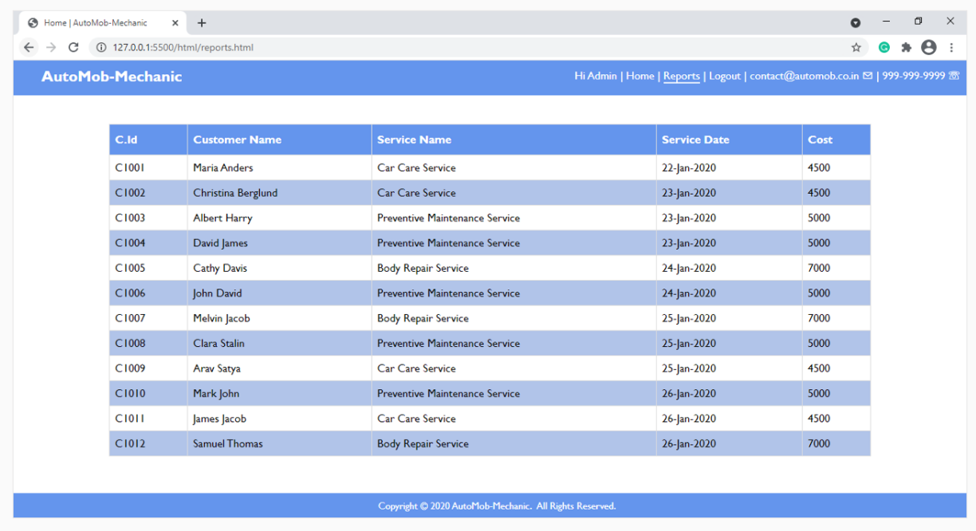

12. Create an UI with **HTML5,CSS3.**

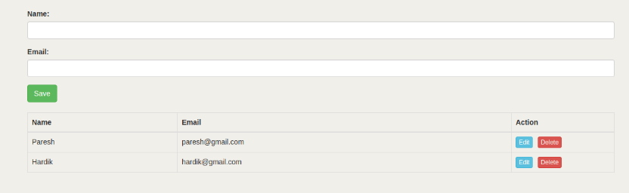

13. Create the calculator using **Html5,Css3 .**.

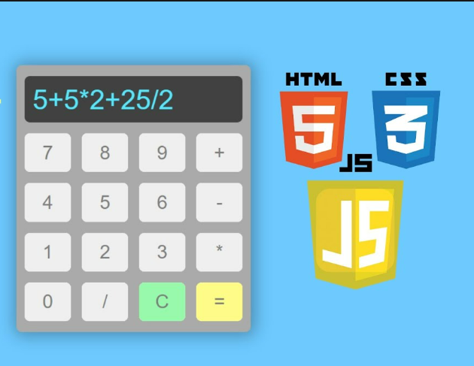

14. Create a sign up form like below.

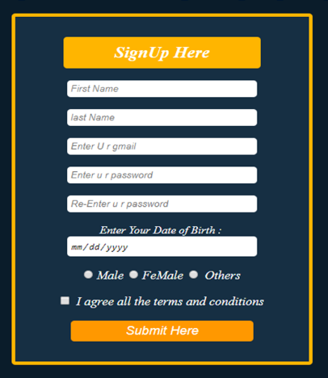

15.Create this UI as it is. Try using same background color and text color. Use FlexBox.

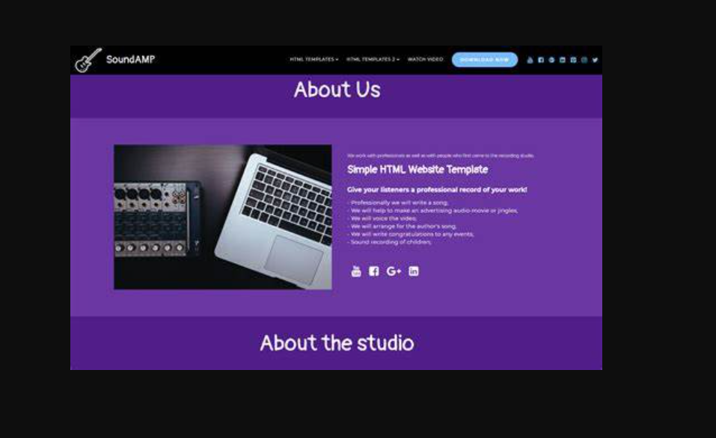

17. Create this page using HTML5 and CSS3.

Q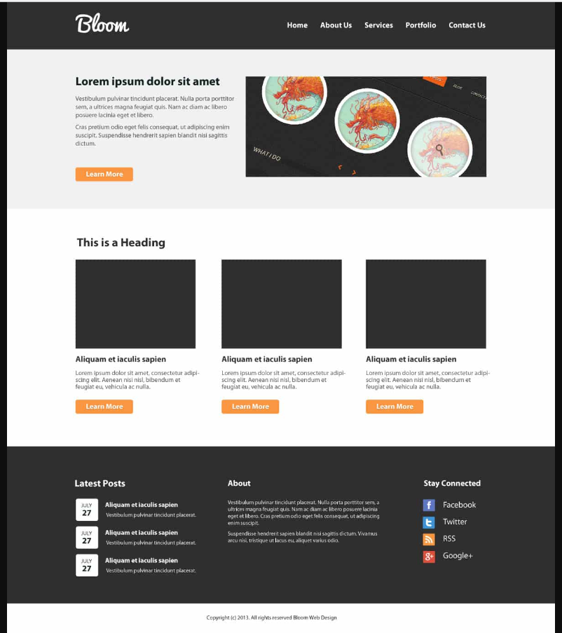

18. Create this page using html5 and css3.

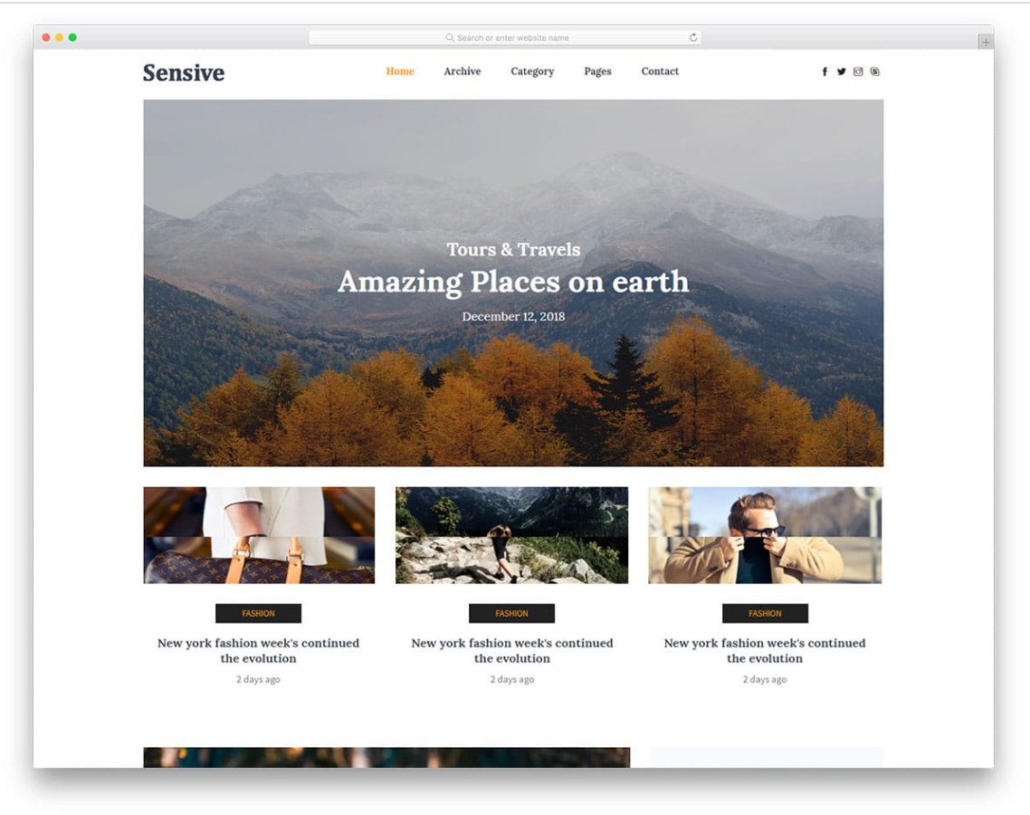

19.Create this page layout using.(Note:4 version of this page should get created)

(i) Using Float

(ii)Using position

(iii)Using Flex

(iv)Using Css Grid

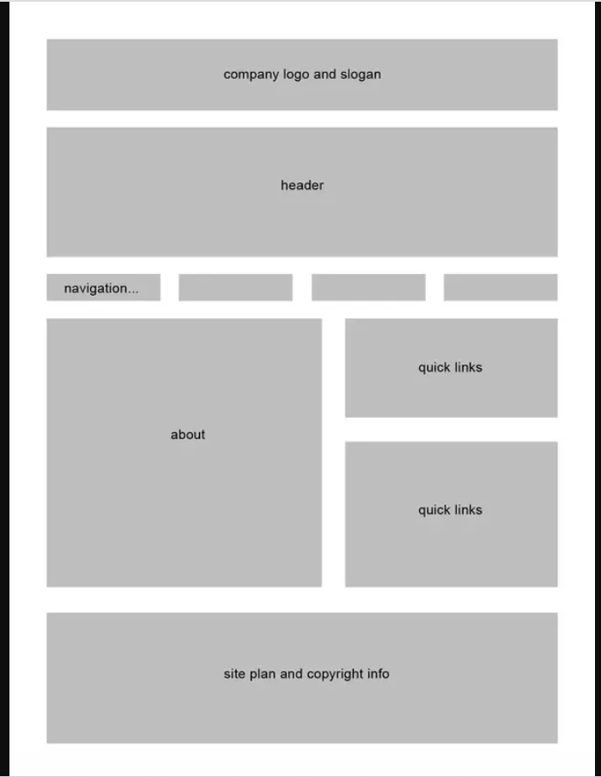

20.Create the layout using HTML5 and CSS3.

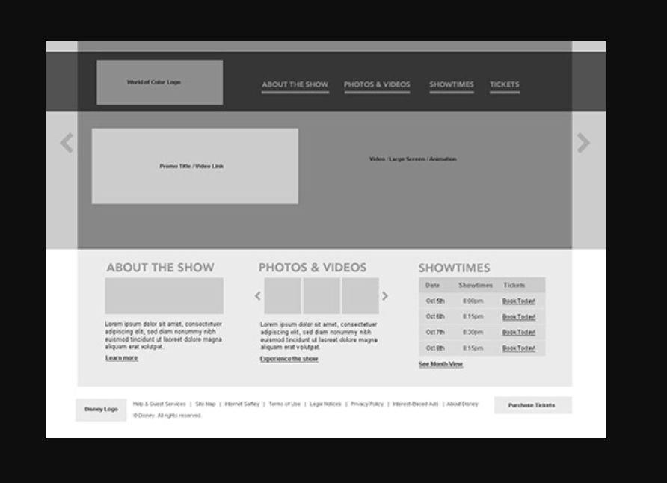

21.Create the below layout as it is. Use all the icons. The UI should be same in your end product.

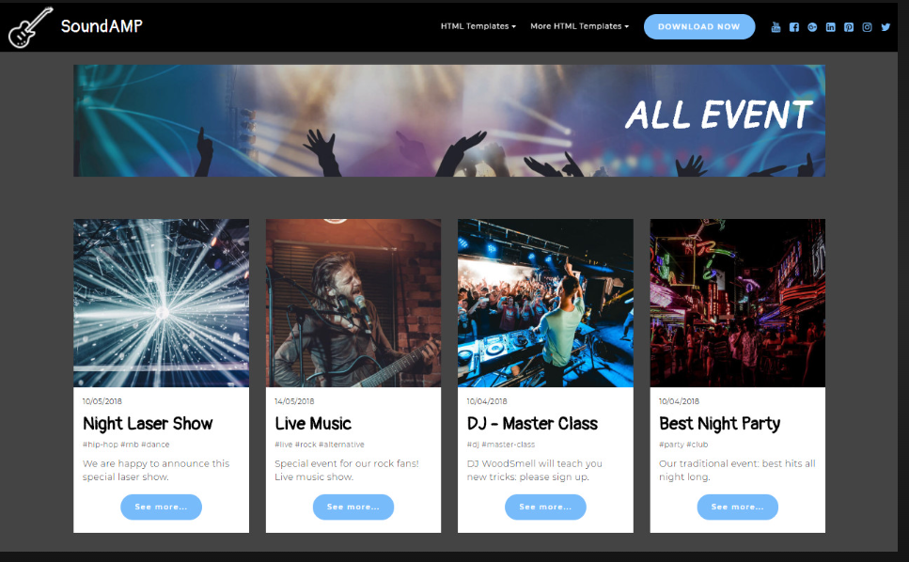

22.Create the layout as it is?



23.Try to imitate the layout .Note(background image can be different. But Laout must be same)

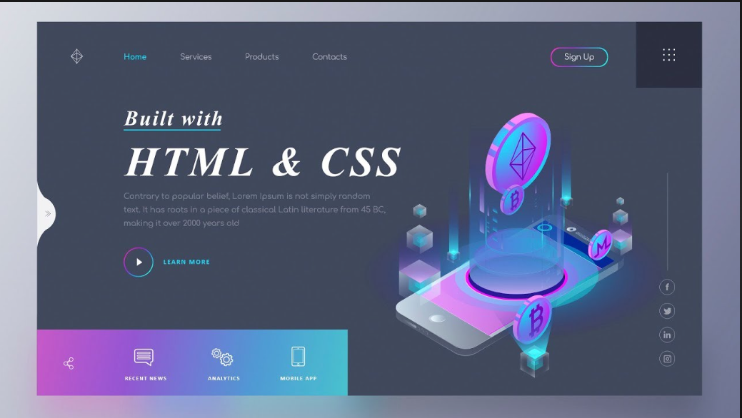

24.Create this layout as it is?

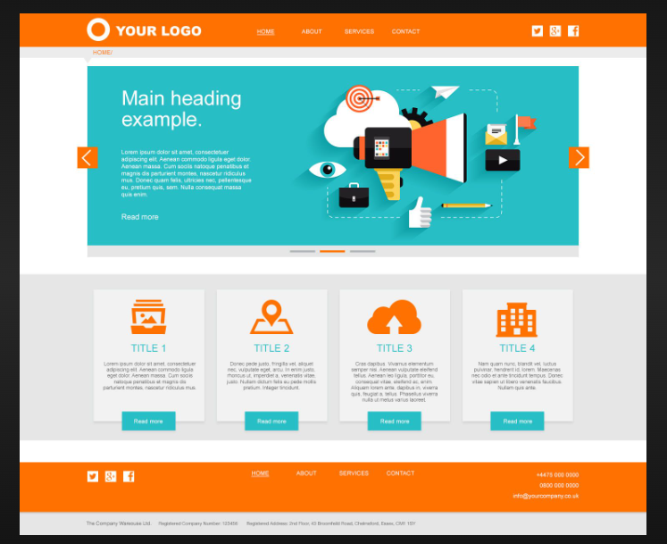

25.Create this layout as it is.

